**F.2 Chapter 2 Solutions**

2.1 The answer is 2n

2.3 (a) For 400 students, we need at least 9 bits.

1. 29 = 512, so 112 more students could enter.

2.5 If each number is represented with 5 bits,

7 = 00111 in all three systems

-7 = 11000 (1's complement)

* 10111 (signed magnitude)
* 11001 (2's complement)

2.7 Refer to the following table:

|  |  |
| --- | --- |
| 0000 | 0 |
| 0001 | 1 |
| 0010 | 2 |
| 0011 | 3 |
| 0100 | 4 |
| 0101 | 5 |
| 0110 | 6 |
| 0111 | 7 |
| 1000 | -8 |
| 1001 | -7 |
| 1010 | -6 |
| 1011 | -5 |
| 1100 | -4 |
| 1101 | -3 |
| 1110 | -2 |
| 1111 | -1 |

2.9 Avogadro's number (6.02 x 1023) requires 80 bits to be represented in two's complement binary representation.

1

2 *APPENDIX F. SELECTED SOLUTIONS*

2.11 (a) 01100110

1. 01000000
2. 00100001
3. 10000000
4. 01111111

2.13 (a) 11111010

1. 00011001
2. 11111000
3. 00000001

2.15 Dividing the number by two.

2.17 (a) 1100 (binary) or -4 (decimal)

1. 01010100 (binary) or 84 (decimal)
2. 0011 (binary) or 3 (decimal)
3. 11 (binary) or -1 (decimal)

2.19 11100101, 1111111111100101, 11111111111111111111111111100101. Sign extension does not affect the value represented.

2.21 Overflow has occurred if both operands are positive and the result is negative, or if both operands are negative and the result is positive.

2.23 Overflow has occurred in an unsigned addition when you get a carry out of the leftmost bits.

2.25 Because their sum will be a number which if positive, will have a lower magnitude (less positive) than the original positive number (because a negative number is being added to it), and vice versa.

2.27 The problem here is that overflow has occurred as adding 2 positive numbers has resulted in a negative number.

2.29 Refer to the following table:

|  |  |  |
| --- | --- | --- |
| X | Y | XANDY |
| 0 | 0 | 0 |
| 0 | 1 | 0 |
| 1 | 0 | 0 |
| 1 | 1 | 1 |

2.31 When at least one of the inputs is 1.

|  |  |
| --- | --- |
| *F.2. CHAPTER 2 SOLUTIONS* | 3 |

2.33 (a) 11010111

1. 111
2. 11110100
3. 10111111
4. 1101
5. 1101

2.35 The masks are used to set bits (by ORing a 1) and to clear bits (by ANDing a 0).

2.37 [(n AND m AND (NOT s)) OR ((NOT n) AND (NOT m) AND s)] AND 1000

2.39 (a) 0 10000000 11100000000000000000000

1. 1 10000100 10111010111000000000000
2. 0 10000000 10010010000111111011011
3. 0 10001110 11110100000000000000000

2.41 (a) 127

(b) -126

2.43 (a) Hello!

1. hELLO!
2. Computers!
3. LC-2

2.45 (a) xD1AF

1. x1F
2. x1
3. xEDB2

2.47 (a) -16

1. 2047
2. 22
3. -32768

2.49 (a) x2939

1. x6E36
2. x46F4
3. xF1A8
4. The results must be wrong. In (3), the sum of two negative numbers produced a positive result. In (4), the sum of two positive numbers produced a negative result. We call such additions OVERFLOW.

4 *APPENDIX F. SELECTED SOLUTIONS*

2.51 (a) x644B

1. x4428E800
2. x48656C6C6F

2.53 Refer to the table below:

|  |  |  |  |
| --- | --- | --- | --- |
| A | B | Q1 | Q2 |
| 0 | 0 | 1 | 0 |
| 0 | 1 | 1 | 1 |
| 1 | 0 | 1 | 1 |
| 1 | 1 | 0 | 1 |

Q2=AORB

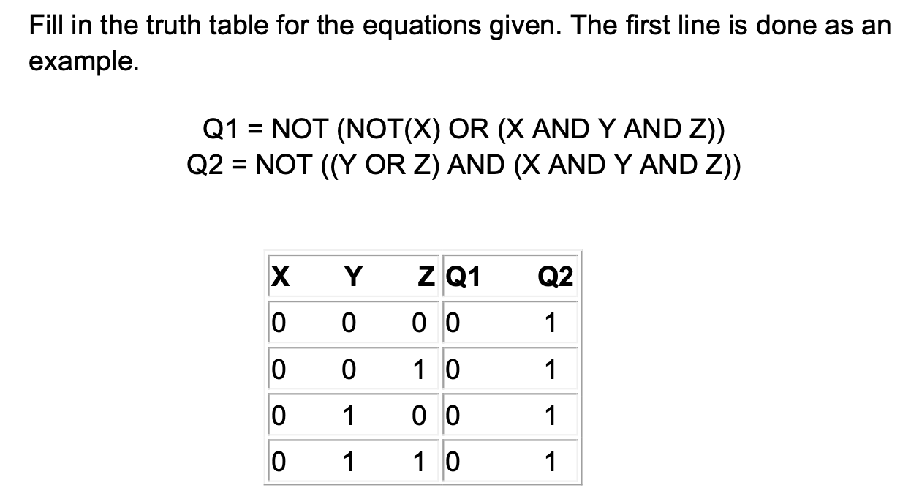2.54

2.55 (a) 63

1. 4n – 1
2. 310
3. 222
4. 11011.11
5. 0100 0001 1101 1110 0000 0000 0000 0000
6. 4(4^m)